Golden Gate Sports Medicine and Orthopaedic Surgery
Nicholas Colyvas, M.D. Elly LaRoque, M.D.
490 Post St., #900
San Francisco, CA 94102
Phone: 415-409-1367
Fax: 415-896-4922
www.goldengatesportsmedicine.com goldengateorthopaedics@gmail.com
______________________________________________________________________________

Driving after Surgery

One of the most frequent questions from surgical patients is “when can I drive again”. The simple answer is that there is no simple answer, except the obvious one: when it’s safe. Determining when it is safe is dependent on a number of factors, many not under a doctors control. While we can provide some advice, we cannot, and do not, determine when you drive again.

There are many studies that show that response times are reduced after different types of Orthopedic surgery. Breaking time response is often used to determine a “safe driving” return. A summary of these is below:

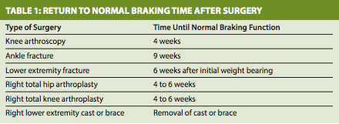

For shoulder surgery, return to driving time may be longer, 6-12 weeks. A recent study (March 2013) had the following conclusion:

“In a new study, shoulder replacement patients showed improved driving performance at 12 weeks, with a significant decrease in the number of collisions in the simulated driving course compared to the tests conducted preoperatively and two weeks after surgery. Results show a statistically significant difference in the mean number of collisions between the first and fourth test”

However these are just guidelines, and may or may not directly or specifically apply to your set of circumstances. What is clear is that insurance companies and law enforcement agencies generally consider the patient to be the only person responsible for determining when he or she is fit to drive. There is no “clearance” or “doctor’s note” that can help if a patient is in an accident or receives a ticket. It is therefore imperative that you determine your safety while driving.

A word about driving while taking pain medications: Patients should avoid driving while taking any narcotics. Narcotics can impair cognitive function and reaction time and could be considered “driving under the influence.”

